**Robotex Estonia rules**

**Team members:** 1 operator and 2 assistants total of **3 members max**.

**Match principles:**

*“1. The match generally contains* ***three rounds*** *and lasts* ***up to three minutes****. The team who will be first to earn two* ***Yuko points (effective points)*** *during the time of the match, will be the winner. Match time is measured during rounds, not between them.”*

*“2. If only one Yuko point has been earned by the end of the match time, the winner is the team who earned it.”*

*”3. If neither team wins any rounds during the match time, the winner will be announced* ***according to the situation of Yusei (dominance)****. Yusei cannot be decided or the number of rounds that has been won is the same for both teams, the match time will be extended by three minutes. If one team earns one or more Yuko points during the extended time, then this team will be the winner.”*

*“4. The contestants have a maximum of* ***30 seconds*** *between the rounds to maintain their robot.”*

**Torinaoshi (repeat of the round)**

The round is repeated in the following situations:

*“1. Both robots are facing each other, and their movement is hindered, or they do not move at all.*

*2. Both robots fall out of the Dohyo at the same time.*

*3. Other situations in which it is not possible to determine who has won or lost.*

*4. If it is not possible to announce the winner after Torinaoshi, the referee may place the robots himself or herself and continue with the match within the allocated time.”*

**Prohibited components of the robot:**

*“1. Any components that may disturb the operation of the opponent (for example, flashlights or jamming devices such as IR LEDs intended to saturate the opponents IR sensors).*

*2. Any components that may damage or scratch the surface of Dohyo. An exception is when the robots collide.*

*3. Any components that are designed to damage the opponent.*

*4. It is forbidden to use any liquids, powders and gas as a weapon against the opponent.*

*5. It is not allowed to use any inflammable materials in the robot.*

*6. The robot must not include any throwing devices (for example throwing a net on opponent).*

*7. The robot must not include any parts, which fix it onto the Dohyo (for example, glues, suction cups, etc.).”*

**Dimensions:**

**Start of the movements:**

* **ROBOT STARTS ON THE WHITE LINE DIAGNOLY TO THE OPONENT!**
* Robot **MUST** be equipped with IR sensor that is placed on the roof of the robot!
* Start of the program must be indicated by **constant flashing LED lights.**

***“If the robot receives the start command, then the LED flashes constantly.”***

* Robot starts movement by detecting and decoding **protocol RC-5** signal from the IR remote control (referee holds the controller).

* IR LED receiver must have frequency – **38kHz.** <https://p1r.se/startmodule/implement-yourself/>

(Prebuilt module that has documentation on how to build your own module)

* Software: RC-5 protocol: <https://p1r.se/startmodule/implement-yourself/> using Hexadecimal format.

**Stopping the movements:**

* **Kill switch** – not mandatory for MiniSumo category**.**
* The referee gives a signal to end the match and stop the robots. The stopping

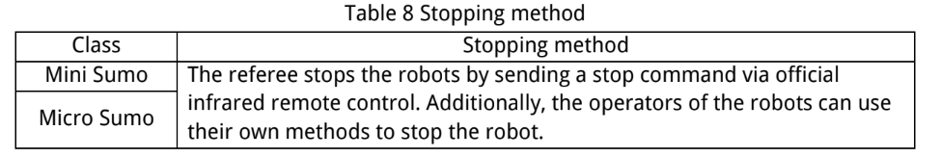***“Method is separately designated for each class.”***